A PHD Word template

Demonstrating sample content

Eirik Hanssen

[Colphon – To be inserted by OsloMet University Library]

Preface

This is a short document to demonstrate how to structure different content in the dissertation word template.

We would like to thank all parties involved in the development and testing of this template!

For support inquires, please contact [ub.forskningsstotte@oslomet.no](mailto:ub.forskningsstotte@oslomet.no)

Eirik Hanssen, Oslo, 2024.12.10

Abstract

Here you would summarize the most important aspects of your dissertation in English.

Sammendrag

Her oppsummeres de viktigste poengene i avhandlingen din.

Contents

Preface i

AbstractB ii

Sammendrag iii

Contents 1

List of Tables 2

List of Figures 2

Publications 3

Definitions/abbreviations 4

1 Introduction 5

2 Theory 6

2.1 Aspect 1 6

2.2 Aspect 2 6

2.2.1 Diving further into Aspect 2 6

3 Method 7

3.1 Research approach 7

3.1.1 Qualitative, quantitative or a Mixed Methods study 7

4 Results and analysis 8

5 Discussion 9

5.1 Main findings 9

5.2 Implications 9

5.3 Conclusion 9

5.3.1 Further research 9

6 Sample content 10

6.1 Figures 10

6.2 Tables 12

6.2.1 Universal Design and accessibility considerations for tables 12

6.2.2 Sample tables 14

6.3 Equations 16

6.3.1 Add an equation 17

6.4 Cross-referencing content in Word 18

6.4.1 Insert a cross-reference 19

6.5 Quotations 21

References 22

Appendices 23

List of Tables

**Table 6.1** A sample table – some celestial bodies and moon count 14

**Table 6.2** A sample table with textual data – some respondent trivia 14

List of Figures

**Figure 6.1** XA sample figure – rising graph 11

**Figure 6.2** Another sample figure – geometric shapes 11

**Figure 6.3** Insert an Equation from the Insert Tab 18

**Figure 6.4** Apply the “Equation” table style from the Table Design Tab 18

**Figure 6.5** Insert a Cross-reference 19

**Figure 6.6** Choose the item to cross-reference 20

Publications

1. [reference] [live DOI URL if applicable] [(status if unpublished)]
2. [reference] [live DOI URL if applicable] [(status if unpublished)]
3. [reference] [live DOI URL if applicable] [(status if unpublished)]
4. [reference] [live DOI URL if applicable] [(status if unpublished)]

Definitions/abbreviations

Template: A preset format for a document or a file

Paragraph style: Settings for the font and layout intended to be used for a paragraph of content.

Universal Design (UD): Our understanding of UD of this document is based on the definitions of UD in the UN Convention on the Rights of Persons with Disabilities (CRPD), and the Norwegian Act relating to equality and a prohibitation against discrimination (likestillings- og diskrimineringsloven). By UD of this document, we mean structuring and organizing this document in such a way that all functions can be used by all people, to the greatest extent possible without the need for adaption or specialized design. UD of this document shall not exclude accessibility technology used by certain groups of persons when there is need for such accessibility technology. In this document, when seeing, (UD) with an instruction it usually means that this step is a UD requirement.

.

1. Introduction

This section introduces the dissertation.

1. Theory

Relevant theoretical aspects are presented in this section.

* 1. Aspect 1

Discussing how Aspect 1 is relevant to this work.

* 1. Aspect 2

Discussing how Aspect 2 is relevant to this work.

* + 1. Diving further into Aspect 2

Discussing further details.

1. Method

Discussing the methods chosen in this work. In this demo document, we will include some sample content to illustrate the proper use of heading and paragraph styles.

The “Method” is a level 1 chapter heading using the Paragraph style called (H1). It will be numbered, and visible in the table of contents.

* 1. Research approach

This is a level 2 subsection and the “Research approach” heading is styled using the (H2) heading. This heading is also numbered and will be visible in the table of contents.

* + 1. Qualitative, quantitative or a Mixed Methods study

Adding a level three heading. This heading is also numbered and will show in the table of contents.

* + - 1. A deeper heading

This is a paragraph under a level 4 heading using the paragraph style (H4). This heading is not numbered, and will not be shown in the table of contents. We have defined six heading levels (H1) to (H6) in the case that more heading levels are needed.

1. Results and analysis

A sample line of text.

1. Discussion

Remember that this is just a suggestion. Choose your own structure.

* 1. Main findings

Some sample text.

* 1. Implications

Some sample text.

* 1. Conclusion

Some sample text.

* + 1. Further research

Some sample text.

1. Sample content

In this section we will include sample figures, tables, equations and quotations to demonstrate how this Word template was designed to include such content, also making sure figures and tables are properly listed properly in the List of Figures and List of Tables. In addition we will discuss how to cross-reference such content within the document.

* 1. Figures

When adding a figure, first begin a new line and write the title of the figure. Use the paragraph style (Fig Title). This style automatically inserts the text label “Figure” followed by the figure number, including the chapter number in front.

See the example below, where the figure is called “A sample figure”:

Note that you should manually insert a line break (SHIFT+RETURN) after the figure number, to make sure that the figure title begins on a line below the figure number label.

A sample figure – rising graph

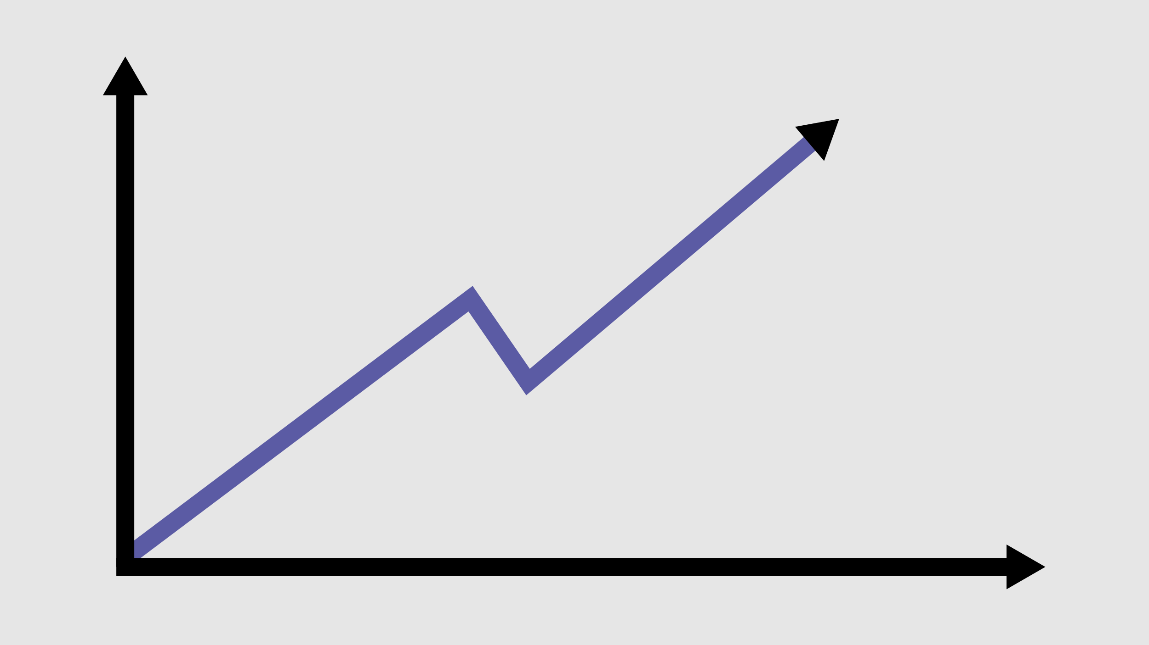

*Note:* While the “Figure Title” should be relatively short. Sometimes it makes sense to have a note below the figure describing it in more detail.

Just a small paragraph before the next sample figure.

Another sample figure – geometric shapes



*Note:* Please remember to add descriptive text to non visual readers. Right click the figure and choose “View Alt Text”. Add a short description that you would like Screen Reader software to read to the users who can’t see the graphic when encountering it.

* 1. Tables

Sometimes data are best presented using a table. In this example we feature the Table Design Tab’s Table styles.

1. Begin with creating the table title and use the paragraph style called (Tbl Title).
2. Then insert a table in the next paragraph.
3. Add the data to your table.
4. Place the cursor in the table and From the Table Design Tab, choose the Table Style called APA 7 – Data for an APA7 formatted table with centered contents in the data cells, or APA7 – Text for an APA7 formatted table with left aligned content.
5. After choosing a Table Style, remember to define the heading row. Note that this must be done after changing or choosing a Table Style as Word will forget heading rows when applying Table Styles.

The APA7 table styles have been designed to mostly replicate the APA7 table setup. «APA7 – Data» has centered columns (from column 2), while «APA7 – Text» has only left aligned contents.

You can override the alignment to suit your needs.

* + 1. Universal Design and accessibility considerations for tables

Adhering to these guidelines will be appreciated by your readers, and especially readers who are dependant on assistive technology to read your tables:

1. A table has it’s own internal structure which can be accessed using assistive technology. Build the tables by inserting a table from the menu in Word. Do not organize characters in such a way as to imitate a table.
2. Remember to define the table heading rows. This must always be done after applying a Table Style, as Word will forget defined heading rows when applying a Table Style. Place the cursor in the first row, or mark the top rows describing the cells in the rows below. Right click and choose Table Properties. In the Row tab, choose “Repeat as header row (…)”.
3. Table is for data, not for layout. Data should be in text form. Do not abuse tables for layout for instance to place two images next to each other. Consider instead to combine those images into one image in graphics software (such as Gimp or Photoshop), and insert *one* image as a figure.
4. As a main rule, do not insert an image of a table as it is not accessible for users of assistive technology. In the rare case you would like to do this, for instance to include an old original graphic of a picture or printed table, you will have to add a textual description of the relevant information in the picture either as alternative text, or described in the text surrounding the figure.
5. Make sure the text is not too small. As a main rule, the table should use the same font settings as the rest of the document which means to use the (Body) paragraph style for the table. If you can’t fit your large table on the page, here are some suggestions:
   1. Insert two section break (new page). For the page between, override the page orientation from portrait mode to landscape mode, as it will accommodate wider tables
   2. Decrease the font size manually, but no smaller than 12pt Arial
   3. A combination of the two above

In the case of rotated pages, OsloMet University Library will rotate these pages back before sending PDF version to print before the Committee review and the defence.

* + 1. Sample tables

The proposed table layout is a starting point, may do manual adjustments to fit your needs.

A sample table – some celestial bodies and moon count

|  | Earth | Mars | Jupiter | Saturn | Uranus | Neptun |
| --- | --- | --- | --- | --- | --- | --- |
| Moons | 1 | 2 | 95 | 146 | 28 | 16 |
| Earth mass | 1 | 0.108 | 317.8 | 95.2 | 14.6 | 17.2 |

*Note:* Remember to manually italicize “Note: ”. After applying the table style, remember to define the header row to make the table more accessible to non visual users.

Tables can span multiple pages, and we also need to make sure that tables are made accessible for non-visual users.

Have a look at the following table which is intentionally made to span two pages and observe that the heading row is repeated on the top of the next page:

A sample table with textual data – some respondent trivia

|  | Favourite Quote | Favourite Color | Favourite Book |
| --- | --- | --- | --- |
| R1 | “Well done is better than well said” (Benjamin Franklin, n.d.) | Blue | Pride and Prejudice |
| R2 | “Be yourself, everyone else is already taken” (Oscar Wilde, n.d.) | White | The Lord of the Rings |
| R3 | “Veni, vidi, vici” (Julius Caesar, n.d.) | Red | Rise and Fall of the Roman Empire |
| R4 | “The only thing we have to fear is fear itself” (Franklin D. Roosevelt, n.d.) | Blue | The Green Mile |
| R5 | “Life is like a box of chocolates. You never know what you’re gonna get.” (Forest Gump, n.d.) | Green | The Catcher in the Rye |
| R6 | “Your time is limited, so don't waste it living someone else's life. Don't be trapped by dogma – which is living with the results of other people's thinking.” (Steve Jobs, n.d.) | Red | 1984 |
| R7 | “It is during our darkest moments that we must focus to see the light.” (Aristotele, n.d.) | Pink | Hamlet |
| R8 | “Do not go where the path may lead; go instead where there is no path and leave a trail.” (Ralph Waldo Emerson, n.d.) | Orange | Moby-Dick |
| R9 | “You must be the change you wish to see in the world.” (Mahatma Gandhi, n.d.) | Yellow | Sophie's World (Sofies verden) |

*Note:* If you don’t like these predefined table styles, you are free to make manual adjustments or even format your own tables from the ground up as you like. This table is formatted using the table style called APA7 – Text table. The difference vs the previous tables is is that the contents are left aligned.

To allow non-visual users to be better aided by their screen reader software when reading a table, and at the same time ensure that the table header is repeated as a table header row when a table spans several pages, please observe these steps:

1. Right click in the first row of the table.
2. From “Table Properties” in “Row” tab, choose “Repeat as header row on top of each page”
3. Click OK to confirm.

Note that if you change a table style from the “Table Design” tab after doing this, you will have to repeat this process, as Word will forget the table header when applying a table style.

* 1. Equations

Depending on the type of thesis, it may make sense to include mathematical formulas and be able to cross-reference them.

A previous version of this template included paragraph styles for Equations which would be numbered by equation number for each chapter, that were intended to be used in an invisible table. However, in use it proved impossible to cross-reference these equations when they were placed in a table, and thus these styles have been removed.

If you need to insert and type equations in Word, you are advised to familiarize yourself with these resources as you will get many tips about writing math in Word:

* [Equations Typing with Microsoft Word's Equation Editor. Can you do everything LaTeX does in Microsoft Word? (Sunny Yu Physics - www.youtube.com)](https://www.youtube.com/playlist?list=PLtLqKaRi3ZvK3UmSBcKFJVReJmyySMsSW)
* [Write an equation or formula (support.microsoft.com)](https://support.microsoft.com/en-us/office/write-an-equation-or-formula-4f799df7-4ca4-4670-afd3-6135768b01d0)
* [Linear format equations using UnicodeMath and LaTeX in Word (support.microsoft.com)](https://support.microsoft.com/en-us/office/linear-format-equations-using-unicodemath-and-latex-in-word-2e00618d-b1fd-49d8-8cb4-8d17f25754f8)
  1. Cross-referencing content in Word

Sometimes we want to refer to something we have written elsewhere in the document. Perhaps you have experienced that you have manually referred to a specific figure, or a chapter, and that later the document has changed so this reference needs to be updated manually. There is a built feature in Word that can save you from this extra work!

If you have used any of the heading styles, or one of (Fig Title), (Tbl Title), it is possible to cross-reference within the Word document to the relevant item.

If you follow this recipe the cross-reference will link to the referred item in the document and in addition, the number of the figure, table, or formula in the cross-reference will also be updated if it later gets a different number because you have changed, added, or removed content.

* + 1. Insert a cross-reference

Follow these steps to insert a cross-reference:

1. From the Insert Tab, insert a Cross-reference, see Figure 6.5.
2. Reference Type: Numbered item
3. Insert Reference Type: Paragraph number (no context)
4. Select to Insert as a hyperlink
5. Find the item in the list which you want to cross-reference:  
   (Figure 6.6)
6. Click the Insert button

Insert a Cross-reference

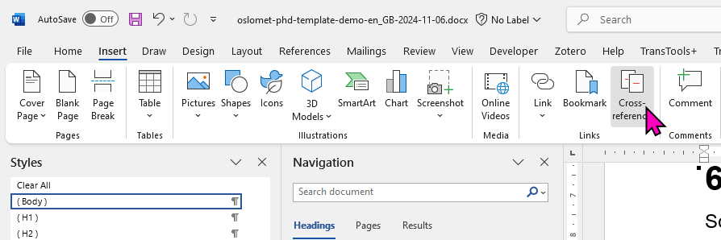

Choose the item to cross-reference

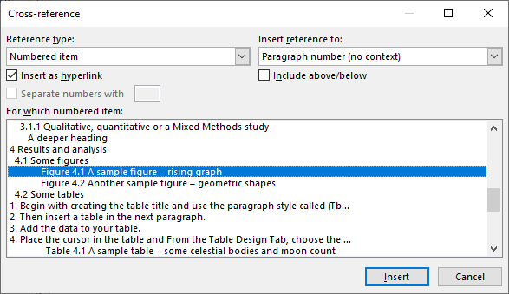

* 1. Quotations

Short quotes are surrounded with quotation marks. Long quotes with at least 40 words should not be surrounded with quotation marks, but instead use the (Blockquote) paragraph style from the Styles panel. Here’s a short quote presented within a paragraph of text: “Science is organised knowledge. Wisdom is organised life” (Immanuel Kant, n.d.).

A quote with 40 words or more should be presented using the (Blockquote) style:

I seem to have been only like a boy playing on the seashore, and diverting myself in now and then finding a smoother pebble or a prettier shell than ordinary, whilst the great ocean of truth lay all undiscovered before me. (Isaac Newton, n.d.)

References

Author, A. A., Author B. B., & Author, C. C. (YYYY). Title of article. *Title of Journal, Volume*(Issue), pages–pages. <https://doi.org/XXXXXXXXXXX>

Appendices

Publications

Publication I

[reference] [live DOI URL if applicable]

Publication status: published

Publication II

Smith, J. & Smith J. (2024). A Relevant Chapter Title. In E. Editor of *Book Title* (Ed.). [https://doi.org/##.####.####](https://doi.org/)

Publication status: published

Publication III

Smith, J. & Surname, N. Manuscript title.

Publication status: manuscript