# **Registration of overtime and «mertid» with Renumerations in the SAP-portal**

Log in to the SAP-portal and choose Renumerations:

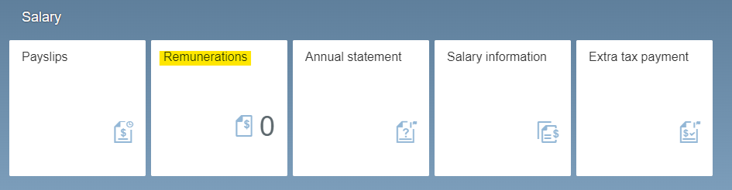

Click «+ Create new», in the lower left on the screen, to generate a new digital form.



## **Purpose**

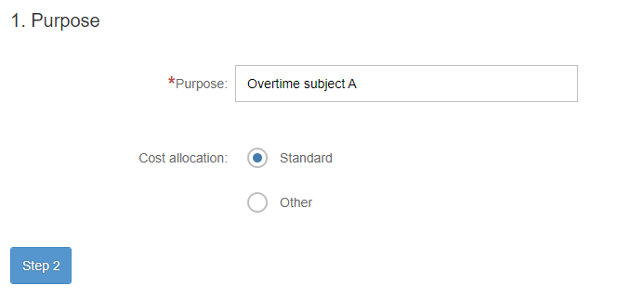

In “Purpuse”, write «Overtime» or «Mertid» as these applies and the name of the subject, project etc. that requires you to work overtime. Please note that overtime has to be mandatory – you cannot choose to work overtime on a given date, you personell leader has to impose overtime.

If the overtime is to be financially charged to your regular cost unit (i.e. where your ordinary salary is charged), please leave “Cost allocation” on Standard.

If the overtime or «mertid» is to be charged to a different budget unit than where your salary is charged, change the cost allocation here. Click “Other». Change «Cost centre» and «K-element 4» to the proper “Kostnadssted” and “arbeidsordre”. **NOTE**: the Cost centre and K-elment 4 used in the picture below are **examples**. They are not to be generally used.

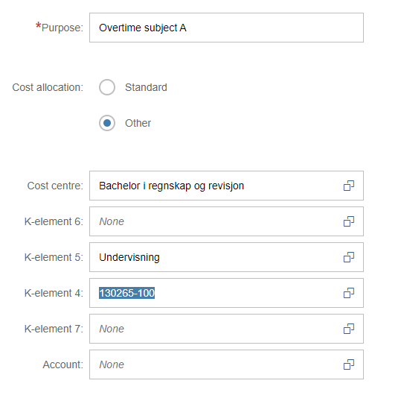

You can use the search field to find the correct Cost centre. You can search using the name of the cost centre and the numbers of the cost centre. Cost center numbers always consists of five digits.

**Example**:

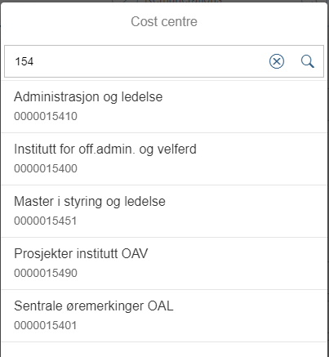

The same search possibilites applies for the «K-element 4» field (used for what in OsloMet is called “arbeidsordre”). The format of «arbeidsordre» varies, but the majority has the format NNNN-100.

**Example:**

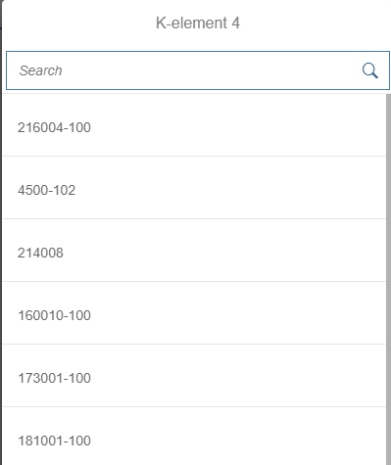

Do not change K-element 5, 6, 7 or “Account”.

Press «Step 2» to continue.

## **Renumerations**

### **Overtime and «mertid» performed on specific dates**

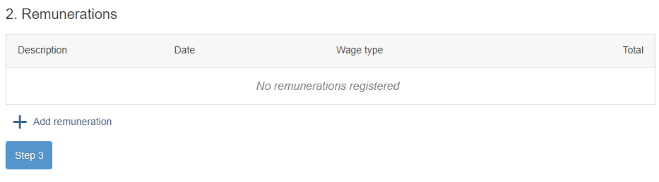

Use + Add remuneration to create the overtime claim, and use + for each new line to be created. You will need to create a new line for each specific date.

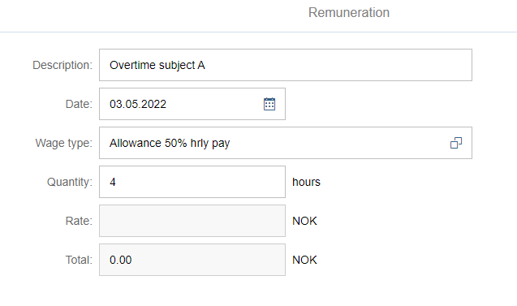

Overtime 50%

**Description**: describe the task/work you preformed in the given dates

**Date**: Date for when the overtime /mertid was performed

**Wage type**: Choose the correct wage type

* 2115 Ekstratimer: for «mertid» if you are employed in less than 100% position and have worked up to 100% position (7:45 or 7:00 hours)
* 2015 Overtid 50%: used for work hours from the end of the workday until 20:00 o`clock
* 2020 Overtid 100%: only used for work performed after 20:00 o`clock during continuous work hours after the end of the workday
  + NB: If you choose to work e.g. to 16:00, have a break and then resume work at 20:00, use code 2015 – the employer is not to be charged extra for flexibility of work hours
* 2065 Lørdag/søndagstillegg: to be used for work on Saturdays and Sundays, in addition to the overtime / mertid. Work on Saturdays and Sundays must be imposed by your leader for the overtime claim to be valid. Choosing to work in weekends does not imply imposed overtime.

**Quantity**: Write the total sum of hours. If you have «factor» (a higher value of work hours than actual hours), include the factor in the sum total.

**Rate and Total** are dependent on your fixed salary and will not be indicated in these fields. The fields will always be blank or state 0.00.

### **Overtime and «mertid» performed over longer periods of time**



Use + Add remuneration to create the overtime pay claim, and use + for each new line to be created.

Overtime and “mertid” over longer periods of time must be distributed over weekly or monthly periods in the Remunerations form.

You will need to create a new line for each specific period.



31.01.22

Overtime for January 2022

Overtime 50%

**Description**: Write the period of overtime / “mertid”

**Date**: The overtime/mertid must be registered on a specific date – use **the last day of the month** for which the overtime applies

**Wage type**: Choose the correct wage type

* 2115 Ekstratimer: for «mertid» if you are employed in less than 100% position and have worked up to 100% position (7:45 or 7:00 hours)
* 2015 Overtid 50%: used for all overtime that applies for longer periods of time

**Quantity**: Write the total sum of hours. If you have «factor» (a higher value of work hours than actual hours), include the factor in the sum total.

**Rate and Total** are dependent on your fixed salary and will not be indicated in these fields. The fields will always be blank or state 0.00.

### **Remunerations overview**

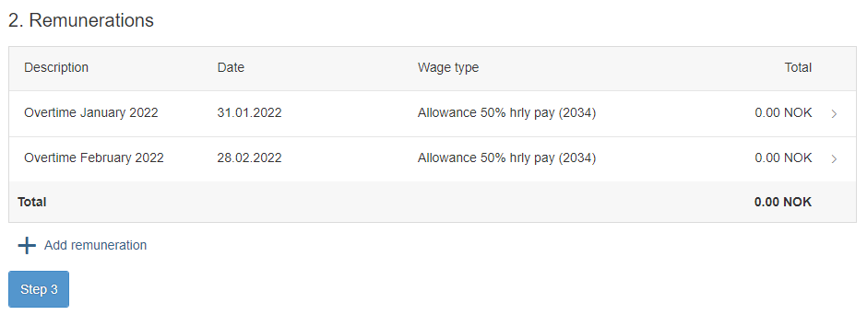

Overtid 50% (2015)

Overtid 50% (2015)

In the Remunerations overview, you must open (click) each line to see the number of hours per period.

Proceed by clicking «Step 3».

## **Attachments**

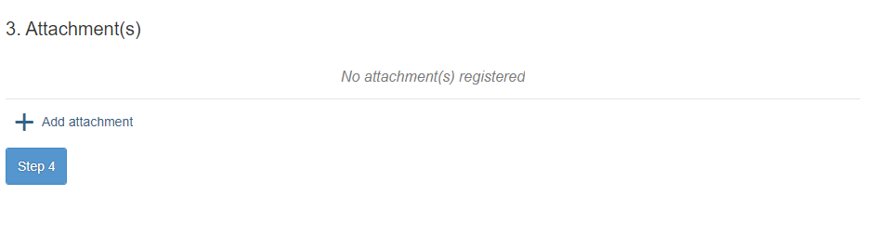

Press + Add attachment(s) to upload attachments. You upload the attachments from where you stored them in OneDrive, Teams etc.

### **Overtime list**

According to the Working Environment Act §10-6, work that lasts beyond the law's limit for normal working hours is overtime work. A completed working time form (called *overtime list*, see <https://ansatt.oslomet.no/en/working-hours>) must therefore be attached to all overtime claims. This list documents that the normal working hours have been fulfilled and that any work after this is overtime or mertid. The working hours form must cover the entire month for which overtime is to be paid. This is at the request of the Office of the Auditor General. The working hours form is filled in as follows:

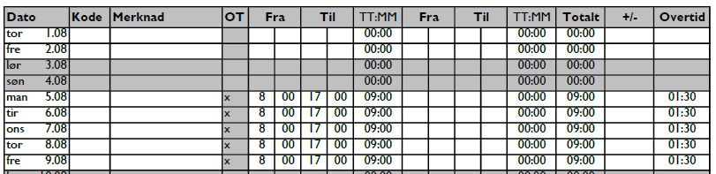

Write the working hours on the relevant dates, so that normal working hours and overtime / mertid are clearly stated. Note that working hours must be filled in with respect to any absence, holiday, etc. Overtime or mertid cannot be accrued on days with complete absence during normal working hours.

Mark column OT with x for the overtime hours, so that excess hours are listed as overtime / overtime and not as flexible hours (for which there is no extra pay).

### **Pre-approval**

Overtime and mertid must be pre-approved by the manager of the budget unit that the hours are charged to. Pre-approval can be in the form of signature of said leader on the overtime list, or as a separate attachment.

**Please note**: All attachments must be in formats PDF, JPG or PNG (common photo formats). This is a technical requirement designated by Tax law, as the documents for payments must not be subjects to change after submission.

## **Saving the overtime list as a PDF document:**

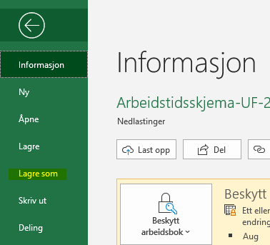In the Excel-form, press «File», in the top menu and choose “Save as”:

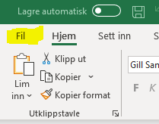

Change the format from Excel workbook (.xlsx) to PDF by pressing the arrow symbol on the far right and choosing PDF (.pdf) from the list:

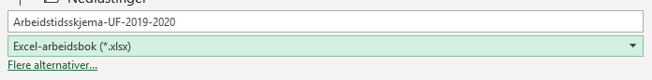



Because the Excel workbook consists of one sheet per month, the overtime list for longer periods than one month have to be saved as several attachments. Example:

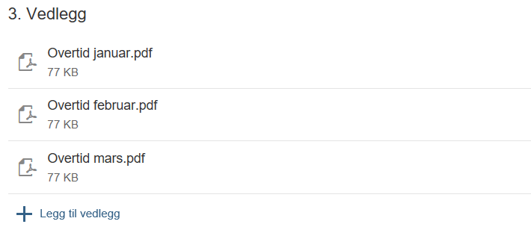

Use “+ Add attachment” to add more attachments.

**Saving an email as PDF:**

Pre-approval by a manager by email must be changed into PDF format before it can be attached to the form.

Open the email, choose «File” and “Print”, then change printer to Microsoft Print to PDF.

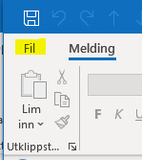 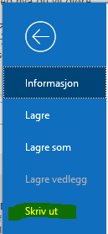 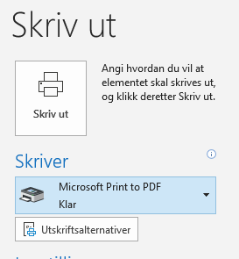

This produces a pdf of the email. Save the email and attach it to the form.

Proceed with Step 4.

## **Comment**

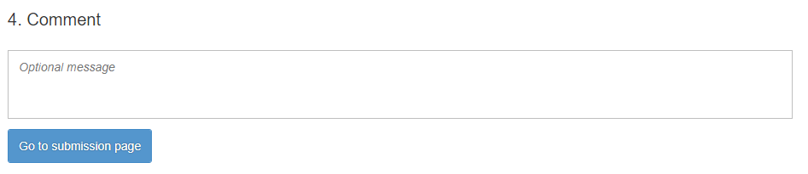

Add any comment to the form. The comments will be available to the administration and to your manager.

Press “Go to submission page” and then “Send” – make sure that you see a **confirmation** that the form is sent before you exit the screen form. You can save the form before submission.

You can see what claims you have submitted and the status of their processing by logging in to the SAP portal, pressing Remunerations and study the overview in the left side of the screen.

Section for payroll

03.05.2022