[Type a quote from the document or the summary of an interesting point. You can position the text box anywhere in the document. Use the Text Box Tools tab to change the formatting of the pull quote text box.]
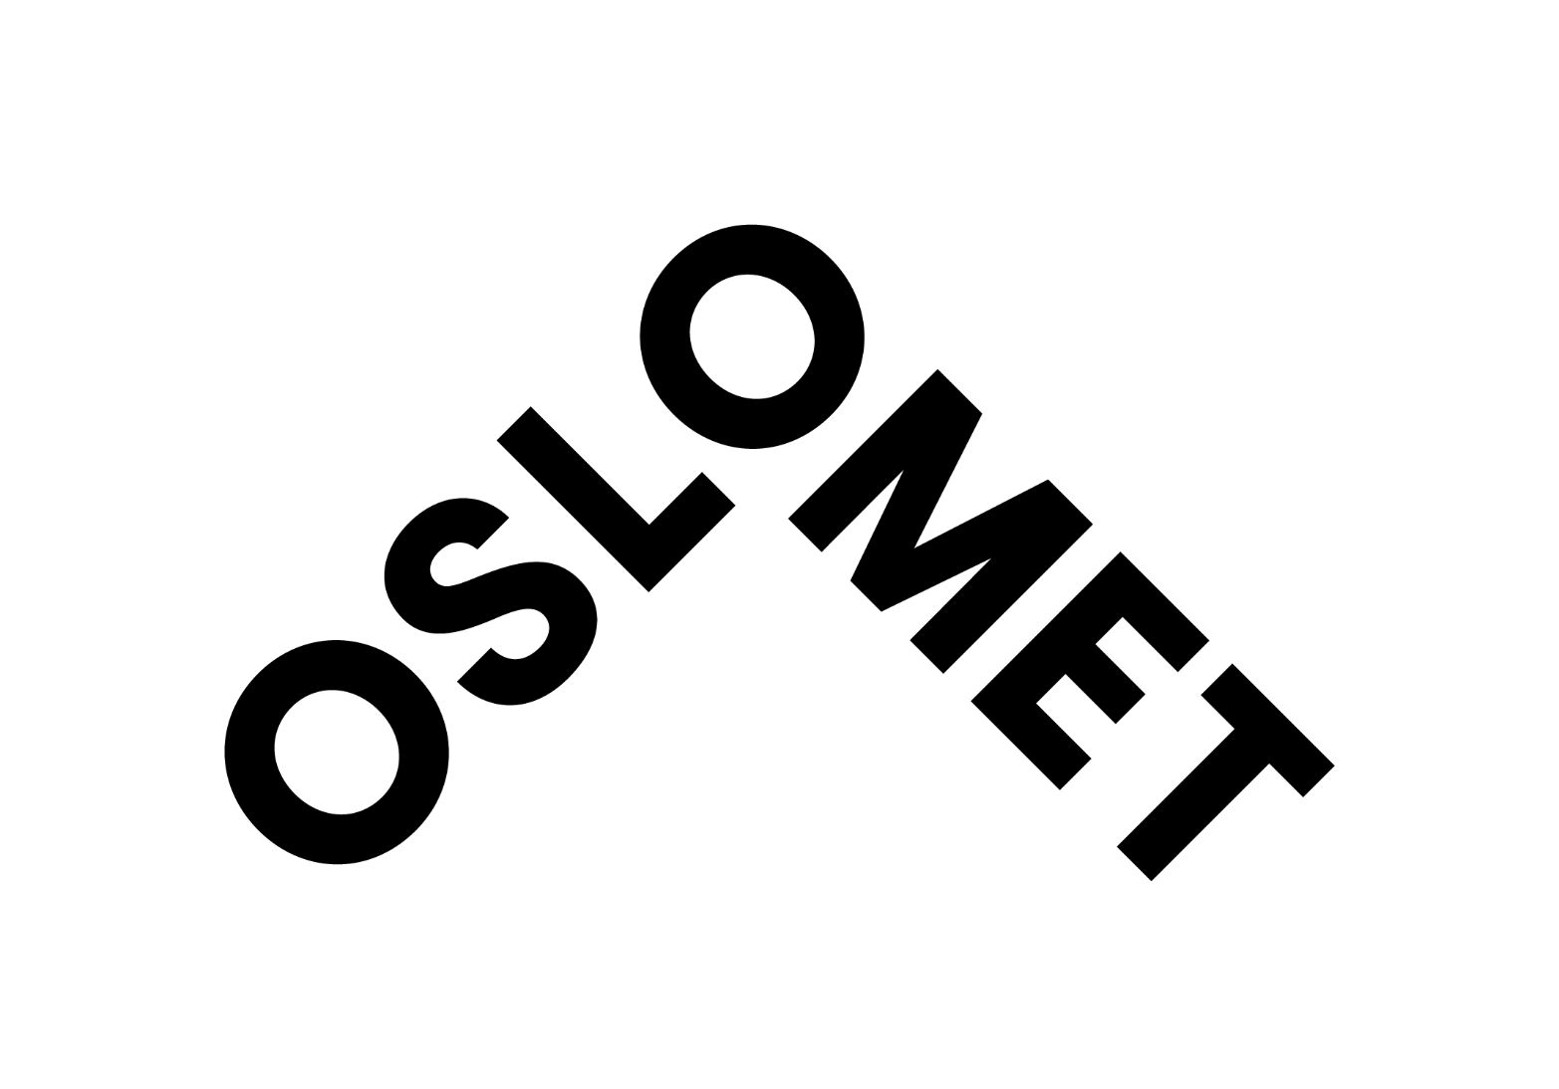

OsloMet - Oslo Metropolitan University is Norway’s third largest university, with more than 20,000 students and over 2000 employees. We conduct research in areas that are important for welfare and value creation, for instance health, education, social sciences, technology and design. OsloMet has an academic stimulating environment with a variety of welfare schemes.

Heading:
Title + area of profession (required)
To be entered in the recruitment system. This heading will show on all recruitment channels when entered as the title in the recruitment system.

Subheading
The heading should be catching the applicant’s attention and make the reader want to read the full announcement. Considered what might draw the target group’s attention. Temporary positions, fixed-term contracts or the number of positions should not put in the heading. The heading may be formulated as a question.

Preferably with a link to the unit’s website. If there is more than one vacant position, this should be stated here. NOTE! Remember to focus on the position; do not include too much general text about OsloMet. Maintain a dialogue with the applicant. Adapt the language to the target group.

Main duties of the position
- Describe the most important duties in bullet points. Use an active and engaging language and text, which targets the desired applicants. Remember to use lowercase first letters and not to use full stops (except when the points contain whole sentences).

We are looking for applicants who have (alternatively, the heading ‘You must have’)
This heading may also be used to give a clearer overview of 'must' requirements and 'should' requirements:
- List the requirements for education and experience (se vedlegg 1 til OsloMets lønnspolitikk for kompetansekravene for den enkelte stillingskode).
- Describe the academic field and experience necessary for the position. Make sure to distinguish between «must have» and «preferred» education/work experience. This will be the guidelines to the process of selecting the candidates.
- Proficiency in both written and spoken Norwegian or another Scandinavian language
- Proficiency in both written and spoken English

To make the overview of must-have and should have requirements, it is an advantage to also use this heading:

It’s an advantage if you have / You should have

We are looking for applicants who
- Describe the desirable personal qualities necessary for the position here. Carefully consider which qualities are necessary for the specific position and in the environment in question. Limit the number of personal qualities to three or four and consider how these can be investigated thoroughly in interviews and interviews with referees.

This point may also be written as prose text. Remember to explain why the specified qualities are important. For example: In this job, you will work in cooperation with others and it is therefore important that you are good at listening and seek good solutions. You must also have good communication skills, both orally and in writing. It is also important that you have the ability to ...

It is important for OsloMet to reflect the population of our region, and all qualified candidates are welcome to apply. We make active efforts to further develop as an inclusive workplace and to adapt the workplace if required.

We can offer you
Some of the points apply to OsloMet as a whole. It is nonetheless important to carefully consider what is relevant to the position, academic requirement in question and what can actually be offered. Describe the environment and base the points on this. Remember that we are selling this specific position. Some suggestions for points could be:

- An exciting job opportunity at Norway’s third largest and most urban university
- to be a part of a dynamic professional environment and unique academic network
- descriptive words about the working environment in the specific unit
- Beneficial pension arrangements with the Norwegian State Pension Fund
- Flexible working hours and good employee welfare arrangements
- Free Norwegian language classes to employees and their partners
- Relocation support, cultural courses and on boarding services
- Working location in downtown Oslo with multiple cultural offers
OsloMet’s International Career Site gives information on living and working in Oslo.
You must upload all of the documents. Original documents and valid passport must be presented if you are invited for an interview. OsloMet performs document inspections in order to give you as a candidate a proper evaluation and ensure fair competition.

If you have documents that cannot be uploaded electronically, please contact Email xxxx

Please note that incomplete applications will not be considered.

Other information
Contact persons must be available during the advertising period and be capable of answering questions about the position. This is important for the candidate’s impression of us as a future employer. It may therefore be a good idea to include a mobile phone number.

If you would like more information about the positon, feel free to contact:
- Position, name, +47 phone number
- Position, name, +47 phone number

The salary for the position is in accordance with the pay scale for Norwegian state employees, job title and position code. Salary NOK xxxx-yyyy annually (dobbeltsjekk lønn i lønnsplanshefte og lønnsspenn fastsatt i OsloMets lønnspolitikk). A higher salary may be considered for particularly well qualified applicants. Law deducts 2% of the salary to the State Pension Fund. Make sure the information is correct and updated.

According to the Norwegian Freedom and Information Act (Offentleglova) your name may be published on the public applicant list even if you have requested non-disclosure. You will in this case be contacted before your name is published.

If you wish to apply for the position, please apply electronically by clicking the button at the bottom of the page.
Note that for English announcement one has to plan the entire recruiting process accordingly. Make sure all candidates are informed if you require applications written in English, and/or if the personal interview will be conducted in English. The recruiting manager and all the interview panel needs to be qualified to assess in English.

Deadline for applications: (minimum three weeks after publication)

Ref.: (case no. in Public 360)

OsloMet has implemented the Charter & Code and been certified by the EU Commission with HR Excellence in Research (HRS4R) and is part of the EU network for mobility of Researchers Euraxess.

